
Department of Engineering and Technology Navi Mumbai
Computer Science and Business Systems

Experiment - 3

Name: Sammar Gaikwad | Roll No: 44
Subject: ITPM | Class/Batch: CSBS / B-2
Date of Performance: 21/08/2026 | Date of Submission:
AIM

- Cost Management of a Web-Based Restaurant Management System.
Theory/Procedure/Algorithm

- Introduction
A Web-Based Restaurant Management System is a software application designed to manage the daily operations of a restaurant through a centralized online platform. The system can handle customer orders, menu management, table reservations, billing, inventory, employee information, and sales reports.
Developing such a system requires effective cost management to ensure that the project is completed within the approved budget while maintaining the required quality. Cost management involves estimating the resources required, preparing a budget, monitoring actual expenses, and controlling cost variations throughout the project.
This case study focuses on the cost management of a Web-Based Restaurant Management System developed for a medium-sized restaurant.

- Project Objectives
The restaurant currently manages orders, billing, inventory, and customer information using manual records and separate software tools. This results in:
- Higher administrative costs.
- Errors in order and billing records.
- Difficulty in tracking inventory.
- Time-consuming preparation of sales reports.
- Increased dependency on manual labor.
- Difficulty in monitoring restaurant expenses.

- Project Scope
The system will include:
- User login and authentication.
- Restaurant menu management.
- Customer registration.
- Online/table-based order management.
- Table reservation management.
- Billing and invoice generation.
- Inventory management.
- Employee management.
- Sales and revenue reports.
- Admin dashboard.
- Database management.
- Backup and basic security features.
The project does not initially include advanced AI-based recommendations, delivery fleet management, or integration with external accounting systems.

- Stakeholders

Stakeholder | Responsibility/Interest
Restaurant Owner | Provides funding and approves the project
Project Manager | Plans and controls project cost and schedule
Software Developers | Design and develop the system
UI/UX Designer | Designs the user interface
Database Administrator | Designs and maintains the database
Restaurant Manager | Provides operational requirements
Restaurant Employees | Use the system for daily operations
Customers | Use ordering/reservation features
System Administrator | Maintains the deployed system

- Project Planning
The project is divided into several activities:
- Requirement gathering.
- System analysis.
- UI/UX design.
- Database design.
- Front-end development.
- Back-end development.
- Integration.
- Testing.
- Deployment.
- User training and maintenance.

- Project Scheduling
The estimated project duration is 16 weeks.

Activity | Duration
Requirement Analysis | 2 weeks
System Design | 2 weeks
Database Design | 1 week
Front-End Development | 3 weeks
Back-End Development | 4 weeks
Integration | 1 week
Testing | 2 weeks
Deployment & Training | 1 week
Some activities can be performed simultaneously to reduce the overall project duration.

- Resource Management
The major resources required are:
- Project Manager.
- Software Developers.
- UI/UX Designer.
- Database specialist.
- Testing personnel.
- Web hosting/server.
- Development computers.
- Internet connection.
- Software development tools.
- Database and security tools.
Resources must be allocated according to project priorities to avoid unnecessary expenditure.

- Risk Management
Risk | Impact | Mitigation
Increase in development time | High | Monitor schedule weekly
Additional feature requests | High | Use formal change control
Hosting cost increase | Medium | Compare hosting providers
Developer turnover | High | Maintain documentation
Software/tool costs | Medium | Prefer suitable open-source tools
Technical problems | Medium | Conduct early testing
Security issues | High | Include security testing

A contingency reserve of 10% has been included to handle unexpected expenses.

- Quality Management
Cost reduction should not compromise system quality. The project should maintain quality through:
- Requirement reviews.
- Code reviews.
- Functional testing.
- Database testing.
- Security testing.
- User acceptance testing.
- Performance testing.
- Regular customer feedback.
Spending more during testing can sometimes reduce future maintenance costs by identifying defects before deployment.

- Project Management Methodology
An Agile methodology can be used for the development of the restaurant management system.
The project can be divided into short iterations or sprints. At the end of each sprint, the team reviews completed features, expenditure, and remaining budget.
For example:
- Sprint 1: Login and user management.
- Sprint 2: Menu and table management.
- Sprint 3: Order and billing system.
- Sprint 4: Inventory management.
- Sprint 5: Reports and administration.
- Sprint 6: Testing and deployment.
Agile helps control costs because unnecessary features can be identified before significant resources are spent on them.

- Monitoring and Controlling
The project manager monitors the following indicators:
- Planned cost.
- Actual cost.
- Cost variance.
- Percentage of budget consumed.
- Remaining budget.
- Development progress.
- Number of change requests.
- Resource utilization.
A weekly cost report can be prepared to identify whether the project is within budget.
If actual development costs begin exceeding the baseline, corrective action should be taken immediately rather than waiting until the end of the project.

- Case Study Description
- A medium-sized restaurant decides to develop a Web-Based Restaurant Management System with an initial budget of $20,350.
- During the first phase, the project remains within budget. During development, however, additional programming effort is required because the restaurant requests modifications to the billing and inventory modules. Development expenditure increases from the planned $10,000 to $10,600.
- The project manager analyzes the variance and discovers that the additional expense is caused by scope changes rather than poor resource management. The manager therefore uses part of the contingency reserve and introduces a formal change-control procedure.
- The team also reduces unnecessary software subscription expenses by using appropriate open-source development tools. As a result, the project remains financially manageable and can be completed without exceeding the approved budget.
- The completed system reduces manual work in order processing, billing, inventory tracking, and report preparation. Although the project requires an initial investment, the restaurant expects lower administrative and operational costs over the long term.

OUTPUT

DashBoard
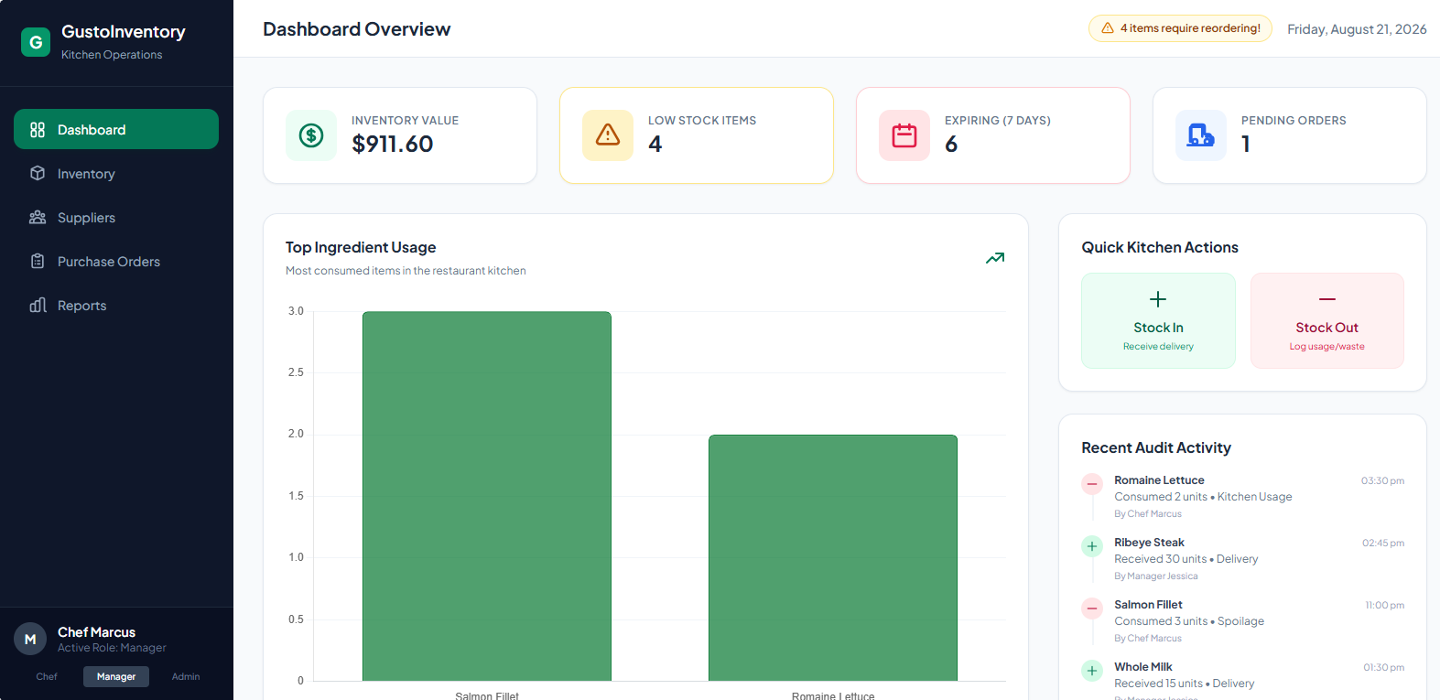

Conclusion

The case study demonstrates the importance of Cost Management in a Web-Based Restaurant Management System. Proper cost estimation, budgeting, monitoring, and control allow the project team to use available resources efficiently and avoid unnecessary expenditure.
The project can be successfully completed within the allocated budget by controlling scope changes, monitoring resource usage, maintaining a contingency reserve, and regularly comparing actual costs with planned costs.
Effective cost management ultimately ensures that the restaurant receives a reliable and useful system while achieving good value for its investment.

Assessment

Timely Submission (7) | Presentation (06) | Understanding (12) | Total (25) | Sign

